SUPYIRE LEXICOGRAPHY PROJECT
Supyire is a language spoken by 350,000+ people in southeastern Mali. The New Testament was published in 2008, the Old Testament is currently being translated, and people are being taught to read and write, but as yet there are no dictionaries.
This project aims to publish a Supyire-French and a Supyire-English dictionary, in both print and digital form, for the use of Supyire speakers and for others who want to use it. We also aim to publish a collection of texts in Supyire that will be available to researchers and will also function as a linguistic and cultural archive of the language and culture.
Through this work, this project will promote both the preservation and development of the Supyire language and culture for the education and benefit of Supyire speakers.

History
In 1980, Robert Carlson began studying Supyire under the auspices of Wycliffe Bible Translators and SIL International. He published a reference grammar in 1994, and has written many articles on the language.
As part of this research, Supyire words have been collected and entered in a database which now has over 11,000 entries.
Many texts have also been collected from 1980 to the present. These are currently in a digital database with nearly 400,000 words.
Since 1990, both the lexical and text collection work has been carried out with the help of Ali Sanogo, of Farakala, Mali

the dictionaries
The current lexical database is in a computer program called Toolbox, developed by SIL. This database needs to be regularized, corrected, and enhanced with more and better example sentences.
After thorough revision, the database must be transferred to another program, FLEx, also developed by SIL. From FLEx, the Supyire-French and Supyire-English dictionaries can be printed, and apps for smartphones can be created. The phone apps will be made available at no or very low cost.

the texts
Currently, the text database is in also in Toolbox.
Selected texts will be formatted, annotated, translated and made available online for research. The annotations will be both linguistic and cultural.
Our goal is to make available online a collection of texts number at least 500,000 words.

our team
We have assembled a small team to work in this project. Robert Carlson and Ali Sanogo will carry on with the work as they are able. They have been joined by two younger men who are currently in training.

Ali Sanogo and Robert Carlson
Ali Sanogo and Robert Carlson have been working together on the dictionary and text databases for over 30 years. Both of them have other occupations which prevent them from devoting themselves full time to the project. Ali has a small holding which he farms to help support himself and his family. Robert is a full time faculty member in the Languages, Linguistics, and Translation Department of Africa International University (AIU).

Robert Sanogo
Robert Sanogo, who is a native speaker of Supyire, will serve as the Supyire language specialist on the team, specifically in the areas of lexicography and text analysis.
Robert has a BA degree in Economic Management from a university in Bamako, Mali. He is currently at AIU in intensive English study. He will join the Linguistics MA program at AIU in January, 2026. All of his work in the AIU graduate program will be devoted to the project.
Robert is committed to working in the project until it’s completion, planned for 2032.

Michael Otieno
Michael Otieno will serve as the information technology specialist for the project. He has worked for Robert Carlson for three years doing data entry and database management.
Mike is currently studying in a computer science program at Africa Nazarene University. To enhance his skills for the project, he will pursue training in linguistics, lexicography, and language documentation at Dallas International University.

organization of the project

management
Administratively, the project is a research project of the Languages, Linguistics, and Translation (LL&T) Department of Africa International University (AIU). AIU is an interdenominational Christian university originally founded by the Association of Evangelicals in Africa. Robert Carlson, who has been a faculty member of AIU since 2005, serves as the project leader. He reports quarterly to the Head of the LL&T Department.
AIU administers the funds for the project. Donations are kept in a US$ account until they are needed, at which point they are converted into Kenya shillings, or whatever other currency is needed.
Two registered charities in the USA are able to receive and transmit funds for the project (see information on making donations below).

budget
The following table gives a summary of the budget, in US$, assuming an exchange rate of $1 = 125 Kenya shillings.
 |  | YEAR 1 | YEAR 2 | YEAR 3 | YEAR 4 | YEAR 5 | YEAR 6 | TOTAL
TRAINING | R. SANOGO | 1,881 | 2,307 | 2,053 | 1,690 | 1,692 | 1,812 | 11,434
 | M. OTIENO | 8,700 | 1,240 | 1,240 | 1,304 | 12,020 | 11,940 | 36,444
 | SUBTOTAL | 10,581 | 3,547 | 3,293 | 2,994 | 13,712 | 13,752 | 47,878
EQUIPMENT | R. SANOGO | 720 |  | 480 | 240 | 480 |  | 1,920
 | M. OTIENO | 720 |  | 480 | 240 | 480 |  | 1,920
 | SUBTOTAL | 1,440 |  | 960 | 480 | 960 |  | 3,840
STIPENDS AND EXPENSES | R. SANOGO | 6,685 | 5,149 | 7,025 | 5,943 | 8,035 | 6,581 | 39,419
 | M. OTIENO | 8,381 | 8,717 | 9,070 | 9,446 | 9,836 | 10,301 | 55,750
 | SUBTOTAL | 15,066 | 13,866 | 16,095 | 15,390 | 17,871 | 16,882 | 95,169
TRAVEL | R. SANOGO | 1,296 |  | 1,360 |  | 1,360 |  | 4,016
 | R. CARLSON | 1,200 | 1,200 | 1,400 | 1,400 | 1,500 | 1,500 | 8,200
 | SUBTOTAL | 2,496 | 1,200 | 2,760 | 1,400 | 2,860 | 1,500 | 12,216
TOTAL Expenses |  | 29,582 | 18,612 | 23,108 | 20,264 | 35,403 | 32,134 | 159,103
Administration |  | 2,958.2 | 1,861.2 | 2,310.8 | 2,026.4 | 3,540.3 | 3,213.4 | 15,910.3
TOTAL |  | 32,541 | 20,474 | 25,419 | 22,290 | 38,943 | 35,348 | 175,013

how to support the project

ways to donate
There are two charities in the US which receive and transmit funds for the project to AIU in Kenya. These charities provide tax deductible receipts for donations.
The prefered method is through the charity International Generosity, which is affiliated with Trust Bridge Global. A second method, if you prefer to use PayPal, is through the charity Christian Leaders for Africa, which is affiliated with AIU.

donate through International Generosity
Go to https://www.internationalgenerosity.com
Click on DONATE NOW
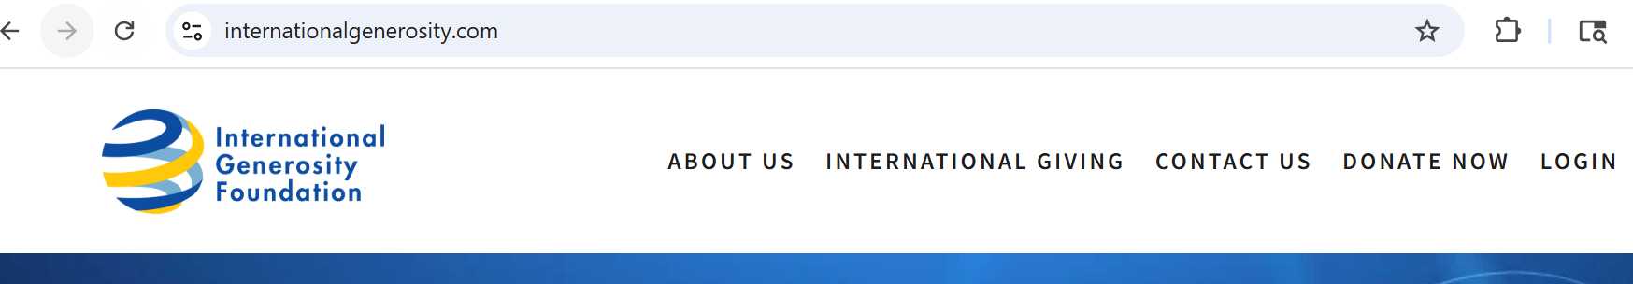
On the page that comes up, under 1 Select a Charity or Fund, select Africa International University (global) (#TGF243189)
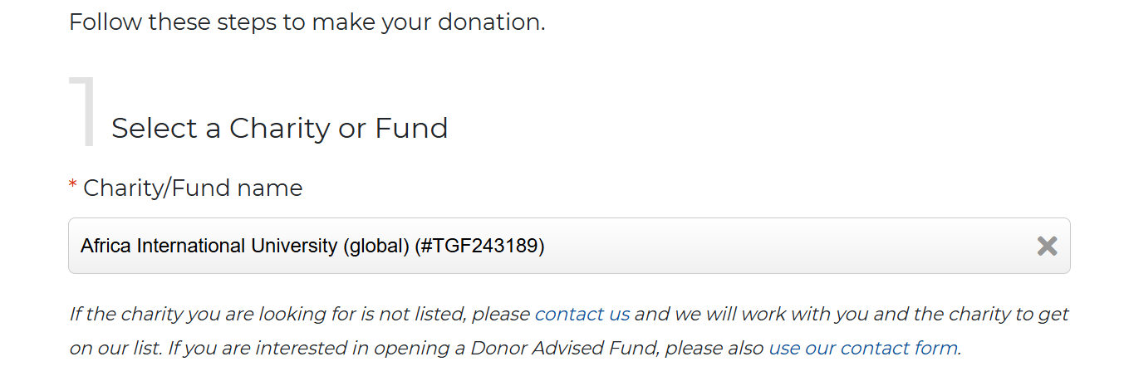
Under 2 (Select a contribution type), choose the method you want to use.
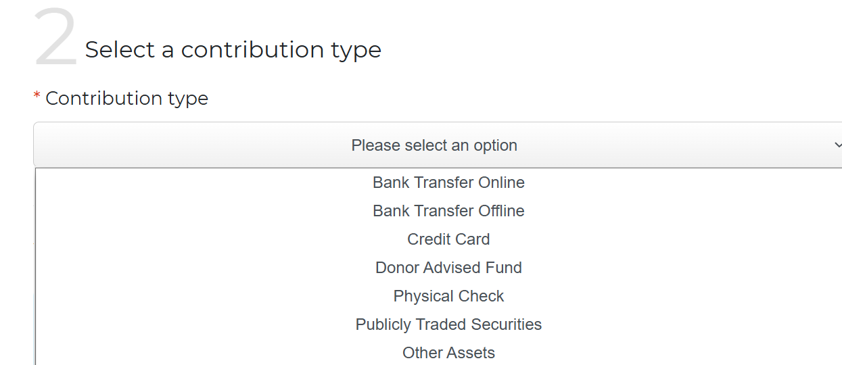
Under 3 (Make a contribution), enter the amount you want to donate.
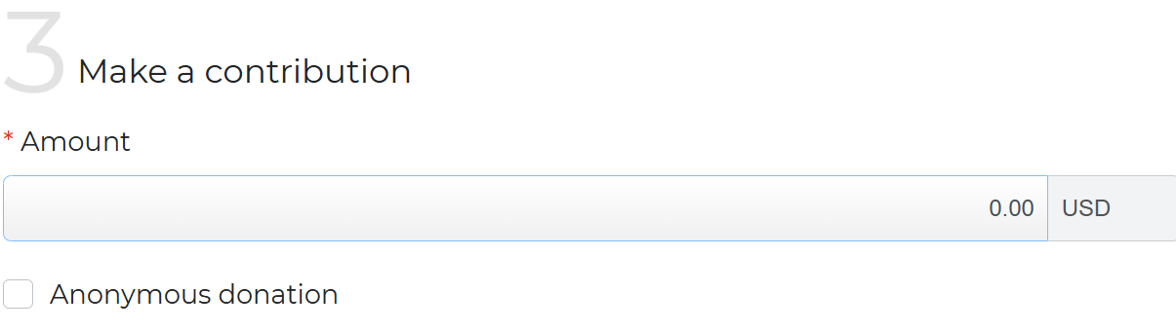
In the box labeled Contribution Purpose, write: Linguistic Project. THIS IS VERY IMPORTANT in order to ensure that your donation goes to the correct account.
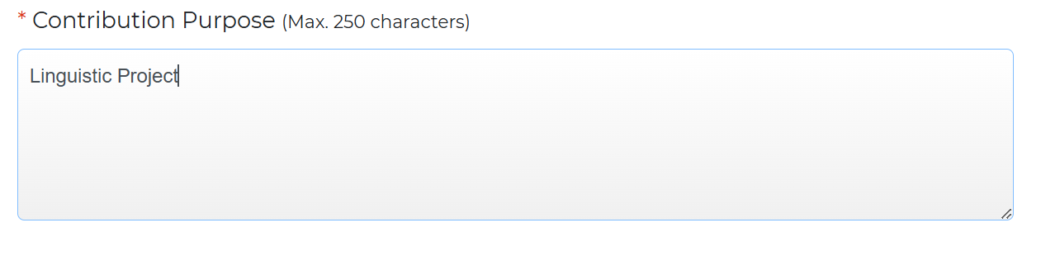
Under 4 (Giver information), fill in the information requested, then click on NEXT.
If the summary of information on the next page is correct, click on CONTINUE TO PAYMENT.
Follow the instructions on the next page. These instructions are different for each contribution type.

donate through Christian Leaders for Africa
Go to https://www.clafrica.com, and click on Donate to CLA.
On the next page, fill in the amount you would like to donate, and choose to pay by PayPal or with a credit or debit card.
In the box labeled Add special instructions to the seller, enter AIU-Linguistic Project. THIS IS VERY IMPORTANT in order to ensure that your donation goes into the correct account.
If you wish to donate through CLA with a physical check, please make the check payable to Christian Leaders for Africa, and indicate on the check or in a note that the donation is for AIU-Linguistic Projcect. Mail the check to
Christian Leaders for Africa
PO Box 3302,
Carmel, IN 46082

if you are not in the USA
If you are not in the USA and would like to donate, please contact us at supyire.lexicography@gmail.com, and we will send you information on how to donate.

contact us
If you want further information, or would like make comments or suggestions concerning the project, or would like to know how you can pray for its success, please contact us at supyire.lexicography@gmail.com.

